**Week 2 SLF4J logging framework Mandatory HandsOn Solutions**

Exercise 1: Logging Error Messages and Warning Levels

Task: Write a Java application that demonstrates logging error messages and warning levels using SLF4J.

Step-by-Step Solution:

1. Add SLF4J and Logback dependencies to your `pom.xml` file:

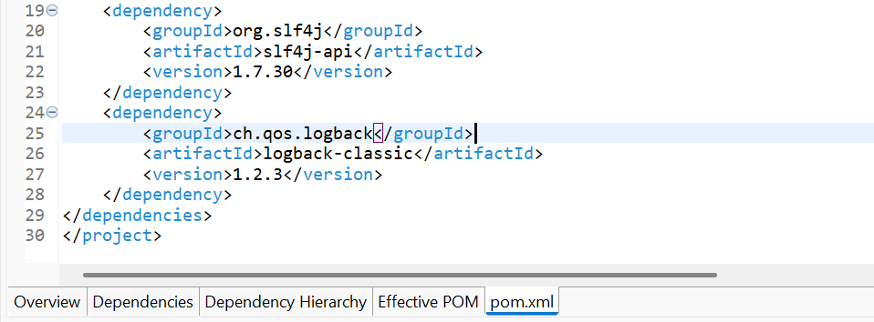

2. Create a Java class that uses SLF4J for logging:

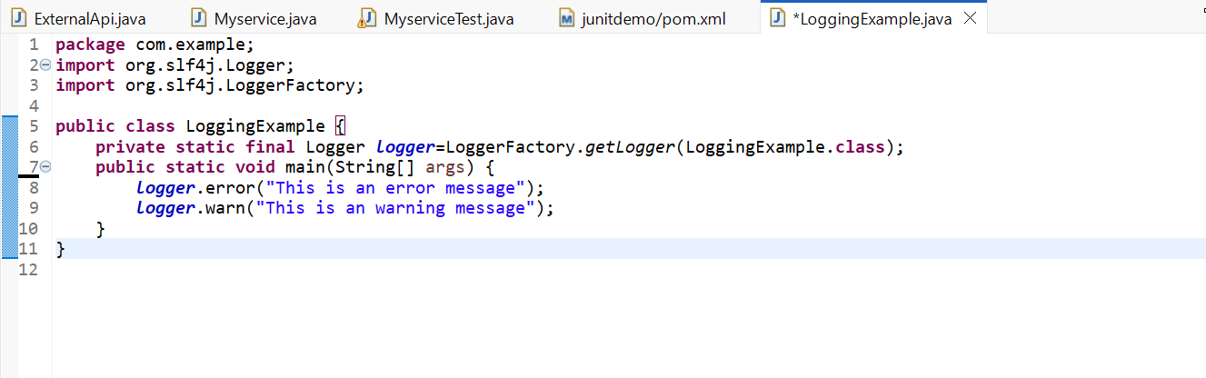

Output:

